
American International University – Bangladesh
Faculty of Engineering
Department of EEE & CoE

MICROPROCESSOR & I/O SYSTEM PROJECT PROPOSAL FORM
SEMESTER: Summer 2018-2019
GROUP#: 4

PROJECT TITLE: Package Sorting and Delivery System.

Goals and Potential Benefits:
We designed a system that will allow us to sort through different parcel packages and deliver them on different routes on a package delivery company like DHL or FedEx; automatically.
We are demonstrating a miniature version of the industrial level sorting and delivery system. The packages we aim to sort and deliver is going to be wrapped with 4 color papers (at a time) depending on their regions. Color sensor will detect the color of the package and send it accordingly to its route. Suppose red color is assigned for region 1, the system will automatically detect the color after acquiring the package and send it to region 4. The whole system will do everything automatically which makes it easier and less time consuming for industries. Also no human error can occur in this system. This system is very easy to construct and for industrial level it is very cheap and efficient.
The components we are using for this project for the miniature version of the delivery system are outlined below.

Apparatus:
1. One 12V, 12000mAh LiPo Battery.
2. One Motor driver.
3. One Rotational Motor (60Rpm).
4. One Color Sensor.
5. One Arduino Uno/ Mega.

Electrical System Block Diagram:
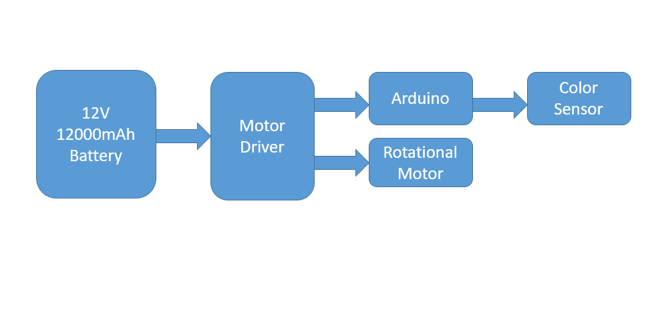

Project Timeline:
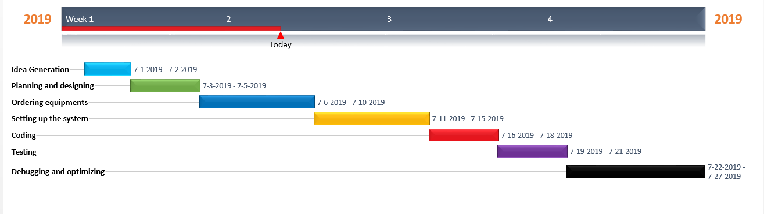

References:
1. AIUB ROBOTIC CREW
2. https://www.arduino.cc

FOR FACULTY USE ONLY
COMMENTS BY COURSE TEACHER:

COURSE TEACHER’S NAME COURSE TEACHER’S SIGNATURE DATE
GROUP MEMBERS
(Maximum FOUR students are permitted to carry out a single Project. However, depending on the capability of the students, less number of students may be allowed)

NAME: Sarkar, Christine Monisha  ID: 16-31255-1  PROGRAM: CSE  ADDRESS: 24/C Indira Road, Dhaka-1215.  EMAIL: christinemonishasarkar@gmail.com  CELL/TELEPHONE NO: 01622344211  SIGNATURE:_____________________ | NAME: ………………………………………………  ID………………………………  PROGRAM: EEE/COE/CSE  ADDRESS:  EMAIL:  CELL/TELEPHONE NO:  SIGNATURE:_____________________
NAME: ………………………………………………  ID………………………………  PROGRAM: EEE/COE/CSE  ADDRESS:  EMAIL:  CELL/TELEPHONE NO:  SIGNATURE:_____________________ | NAME: ………………………………………………  ID………………………………  PROGRAM: EEE/COE/CSE  ADDRESS:  EMAIL:  CELL/TELEPHONE NO:  SIGNATURE:_____________________

NAME:  ID:  PROGRAM:  ADDRESS:  EMAIL:  CELL/TELEPHONE NO:  SIGNATURE:_____________________ | NAME: ………………………………………………  ID………………………………  PROGRAM: EEE/COE/CSE  ADDRESS:  EMAIL:  CELL/TELEPHONE NO:  SIGNATURE:_____________________
NAME: ………………………………………………  ID………………………………  PROGRAM: EEE/COE/CSE  ADDRESS:  EMAIL:  CELL/TELEPHONE NO:  SIGNATURE:_____________________ | NAME: ………………………………………………  ID………………………………  PROGRAM: EEE/COE/CSE  ADDRESS:  EMAIL:  CELL/TELEPHONE NO:  SIGNATURE:_____________________
REMARKS (for OFFICE use only)

